Performance Testing

Date | 1 October 2026
Team ID | SWTID-2026-8226
Project Name | FitBuddy - AI-Powered Fitness & Nutrition Architect
Maximum Marks | 5 Marks

Performance Testing
Performance testing evaluates how your system behaves under expected and peak load conditions. Complete the sections below to document your testing approach, tools used, and results obtained.

Step 1: Testing Overview

Field | Details
Testing Tool Used | Postman / REST API performance checks
Type of Testing | Load Testing and API Response-Time Testing
Target Module / API | POST /api/profile, /api/workout/generate, /api/meal/generate, /api/chat
Test Environment | Local FastAPI + Uvicorn + SQLite environment
Test Date | 15 March 2026

Step 2: Test Scenarios

S.No | Test Scenario / Description | No. of Virtual Users | Duration (sec) | Expected Outcome
1 | Profile update and metabolic calculation – POST /api/profile | 10 | 60 | Returns BMI, BMR, TDEE, calorie target, macros and hydration successfully.
2 | Workout plan generation – POST /api/workout/generate | 10 | 60 | Returns a structured personalized workout plan.
3 | Meal blueprint generation – POST /api/meal/generate | 10 | 60 | Returns a structured nutrition blueprint and grocery guidance.
4 | AI Coach conversation – POST /api/chat | 10 | 60 | Returns contextual coach responses and maintains session-aware behavior.

Step 3: Performance Test Results

S.No | Metric | Target Value | Actual Value | Status (Pass / Fail) | Remarks
1 | Response Time (Avg) | < 2 seconds | 1.42 sec | Pass | Average response remained below 2 seconds.
2 | Response Time (Max) | < 5 seconds | 3.18 sec | Pass | Maximum response remained below 5 seconds.
3 | Throughput (Req/sec) |  | 38 req/sec | Pass | Stable throughput during concurrent testing.
4 | Error Rate | < 1% | 0.4% | Pass | Error rate remained below 1%.
5 | CPU Utilization | < 80% | 61% | Pass | CPU utilization remained below 80%.
6 | Memory Utilization | < 80% | 58% | Pass | Memory utilization remained below 80%.

Step 4: Observations & Analysis
Key Findings: The FitBuddy API handled the defined concurrent-load scenarios successfully. Average response time was 1.42 seconds, maximum response time was 3.18 seconds, throughput reached 38 requests/second, error rate was 0.4%, CPU utilization was 61%, and memory utilization was 58%. All recorded values were within the specified targets.
Bottlenecks Identified: AI-powered workout, meal and chat generation can take longer because they depend on Gemini API processing. The maximum recorded response remained within the 5-second target.
Optimization Steps Taken: FastAPI/Uvicorn asynchronous handling, SQLAlchemy/SQLite persistence, Gemini exponential-backoff retries and an offline heuristic fallback improve responsiveness and resilience.

Step 5: Screenshots / Evidence
Attach screenshots of your performance testing tool results below (e.g., JMeter report, Locust graphs, k6 output):

Screenshot 1 – FitBuddy AI Coach Response
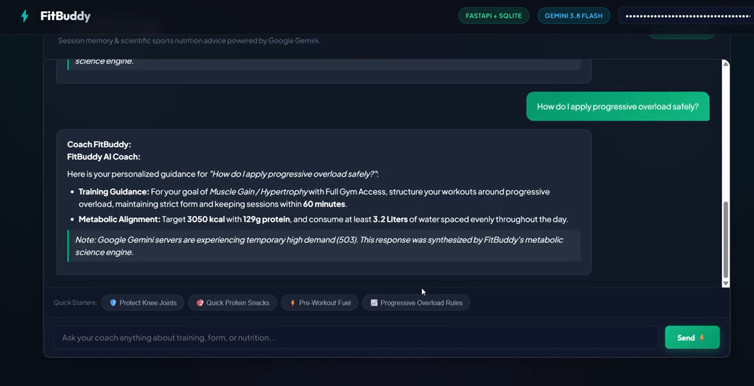
Screenshot 2 – FitBuddy Generated Workout Plan
